Will Shasta Elementary School return to In-Person instruction after Thanksgiving Break?
Shasta will continue with the Health and Safety protocols and hold five days a week In-Person instruction starting on November 30, 2020. Even though we are asking you to keep children home if they are sick, we are still required to track attendance and work with families whose children are missing many days of instruction.

Will my child have to wear a mask at school? What type of mask is needed?
Yes. All students (and staff) in grades TK to 8th grades will be required to wear a face
covering (mask) at school by governor’s order to enter and exit, ride the bus, as well as travel throughout the buildings. All Students in TK to 8th grades will be required to wear mask within the classrooms which is a change from California Public Health.
Mask minimum requirements:
• Mask must cover mouth & nose
• Mask must sit flush or create a seal to the face
• If using a shield, there must be a drape that comes down off the bottom or a mask.
Examples:
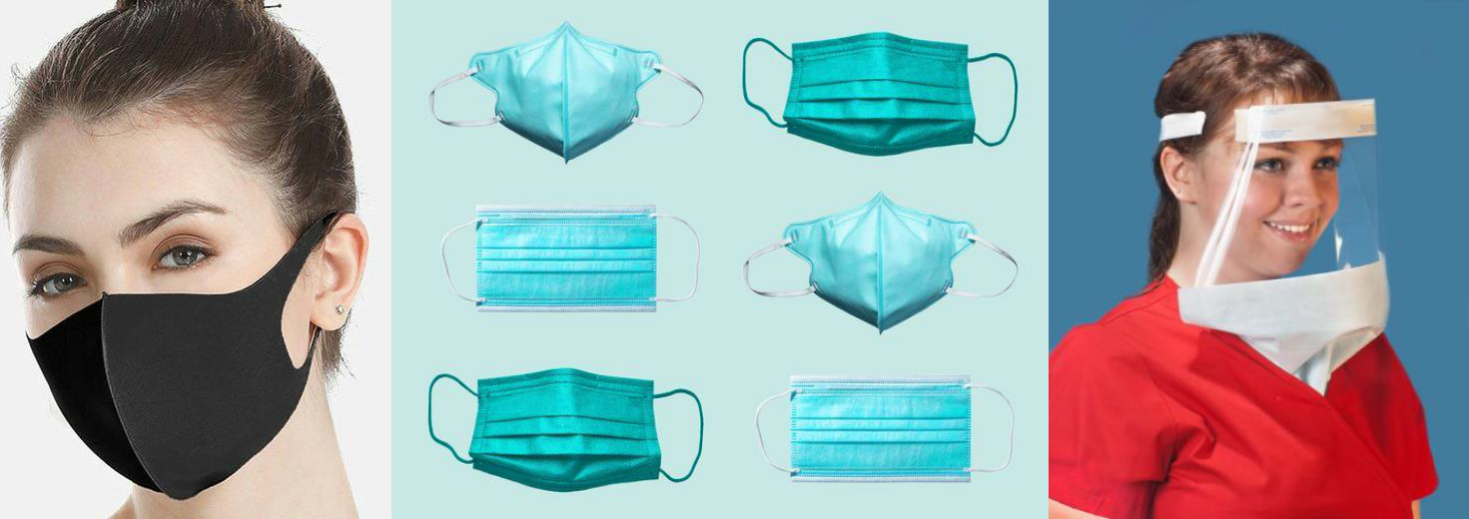

What will social distancing look like at the school?
Students will remain in the same cohort (group) with the same teacher during the day to the greatest extent possible, including during recess and lunch, to limit intermingling with other students. Desks are spaced within the classrooms to follow the Shasta
County Health guidelines. Materials within the classrooms will be allocated for individual use when possible. Frequent handwashing and/or use of hand sanitizer will be occurring. Staff will be positioned 6 feet between themselves and students as much as is practicable.

Will the school be temperature screening students?
No. We are asking that all families take the temperature of their child each morning and screen for illness. If your child has a temperature of 100.4 or higher you are to keep them home. If your child is sick, please keep them home. Call the school as normal to
let us know. We will take the temperature of students who are showing signs of
being ill, as we have always done. We will be asking staff to do visual checks of students as they arrive.

Will my child have PE and recess? What about sports?
Yes. PE will still be happening as required. We are making schedules that keep cohorts intact during recess and lunch times with designated play areas as much as we can. All fall sports are postponed at this time. Masks are not required when playing outside during PE or recess.

What happens if there is a positive case at school?
The school will work with public health on communication and protecting privacy. A confirmed case will result in a cohort being put on distance learning protocols with their current teacher for 14 days. The entire school community would be informed that there was a case at the school. Public Health requirements state that if 5% of the school population (staff and students) is concurrently infected the entire campus should go to Distance Learning. Example: Shasta Elementary 140 staff/students * 5% = 7 members out with COVID-19. Our campus has had no confirmed cases to date, so we have not met this rule.

What would be the conditions to move all students to Phase 1 (Distance/Virtual Learning)?
If California Public Health in conjunction with the State Legislature or Governor’s Offices mandated Distance Learning for all, Shasta Union Elementary School District would comply.

What does the Distance/Virtual Learning look like?
Distance Learning will be a daily live interaction using Zoom to engage students with their teacher and peers. This interaction is defined as two-way communication. The focus of these interactions will be English Language Arts and Mathematics. Other learning activities will be completed by students’ offline with guidance from their teacher.

Will visitors be allowed on campus?
The school will be limiting visitors, including parents. Office access will still be open with health and safety protocols. Call the school for appointments if a meeting is required.

